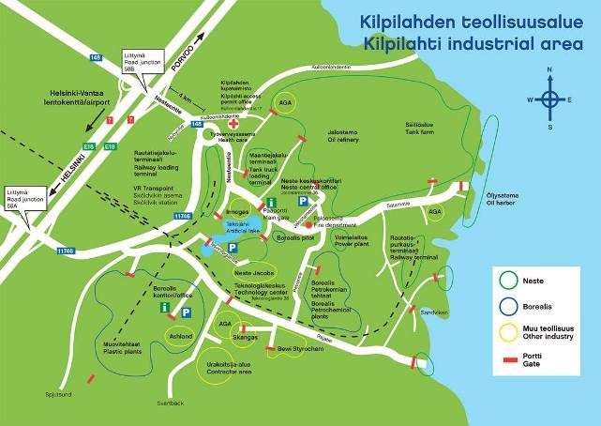

Driving instructions to Borealis Catalyst Pilot – BC Pilot – in Porvoo
The easiest way to get to Borealis BC*Pilot is by car or taxi. Borealis Porvoo is located in Kilpilahti industrial area. The street address to Borealis BC*-Pilot is Teknologiantie 95-18, 06850 Kulloo.
- From Helsinki or Helsinki-Vantaa Airport it takes about 40 minutes to Borealis Porvoo. Kilpilahti/Sköldvik lies some 40 km east of Helsinki and soma 15 km southwest of Porvoo downtown.
- When leaving Helsinki-Vantaa Airport, follow the signs “Kehä III itään” and “Porvoo, Kouvola, Kotka”. Kehä III is road number E18 and also 50. Merge onto E18 Porvoonväylä.
- On E18, follow the signs “Porvoo, Kouvola, Kotka”. Drive the motorway E18 about 18 km.
- Take the E18 exit to road number 11746 toward ”Kilpilahti, Sköldvik”.
- NOTE! Ignore the Borealis signs as they lead to Borealis Plastics Plants.
- Drive 4 km and turn in the roundabout to right to Nesteentie following the Neste sign.
- Drive the road to Neste main gate. If you take the middle lane, there is no need to pull out.
- After the main gate, turn to right toward Grace catalyst and BC*-pilot.
- After the small slope, drive directly to the parking place where passenger cars can be parked. Good vehicles can drive directly to the green gate which can be seen when entering the parking place.
- There are no special parking spaces for visitors. The car can be parked in any free parking space or drive to the right hand site to sand path which leads to the catalyst pilot entrance gate. The car can be parked in the widening in front of the entrance door.

- When arriving form Porvoo:
- Take the E18 exit 58B to road number 148 toward “Kilpilahti, Sköldvik”.
- Drive 2.2 km to the roundabout and continue straight forward toward Neste. Ignore the Borealis signs as they lead to Borealis Plastics Plants.
- Drive the road to Neste main gate. If you take the middle lane, there is no need to pull out.
- After the main gate, turn to right toward Grace catalyst and BC*-pilot.
- After the small slope, drive directly to the parking place where passenger cars can be parked. Good vehicles can drive directly to the green gate which can be seen when entering the parking place.
- There are no special parking spaces for visitors. The car can be parked in any free parking space or drive to the right hand site to sand path which leads to the catalyst pilot entrance gate. The car can be parked in the widening in front of the entrance door.

